**Databases – Task 2 – SQL level up!**

***Scenario:******PlayMoreGames.co.uk - Reviewer Database***

*PlayMoreGames want to be able to allow visitors to setup review accounts. You have been asked to create the database.*

**Screenshot** your Schema and add it to your document. 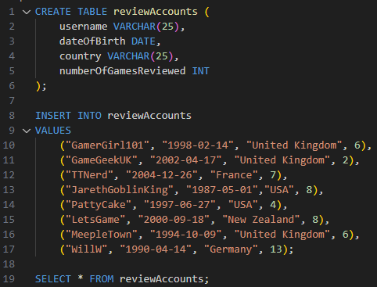

**Tasks:**

1. Carry out queries to show:
   1. Usernames of every member who has reviewed more than 6 games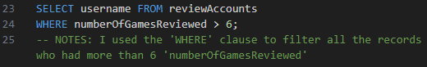
   2. All data of members from the UK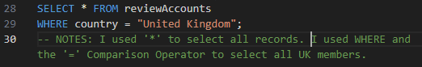
   3. Usernames and DOB of every member born after 01/01/2000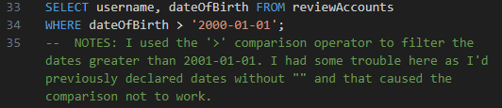
   4. The average number of reviews
   5. The total (sum) number of reviews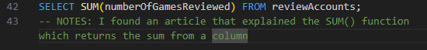
2. Update the following:
   1. Update PattyCake’s review total to 8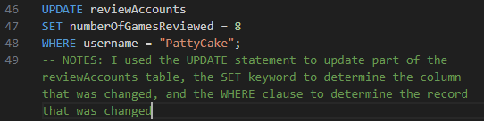
   2. Update GamerGirl101 review total to 11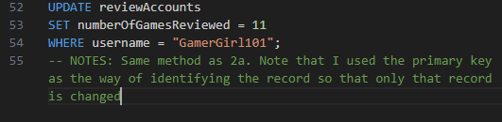
3. Carry out queries to show:
   1. Usernames that begin with ‘G’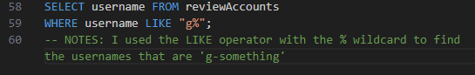
   2. Usernames and review counts for users who have submitted between 6 and 8 reviews 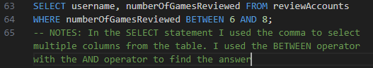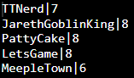

Questions:

1. Which field have you identified as a suitable candidate for a primary key and why is this the most suitable?

**I used the username as the primary key assuming that when creating a username you will be restricted to choosing one that is unique from those existing making each one unique/distinct**

1. What other data might be useful to capture for a database like this?

* **A boolean record for each game the site runs: true if reviewed, false otherwise**

**or maybe a VARCHAR(255) which is null if unreviewed and contains the review if reviewed**

* **A date record for the last time a user submitted a review**
* **An integer record for the number of games the user has played**
* **A date for when the user created their account**
* **A VARCHAR for account type eg standard/premium**

**Submit all your work and send it to your tutor in a word document or similar.**

**NOTES:**

**\* Date field types: See this reference**  
[**Date Functions in SQL Server and MySQL (w3schools.com)**](https://www.w3schools.com/sql/sql_dates.asp)

So in your database, when you INSERT INTO, your date format for the 20th April 2023 will be:   
 ‘2023-04-20'